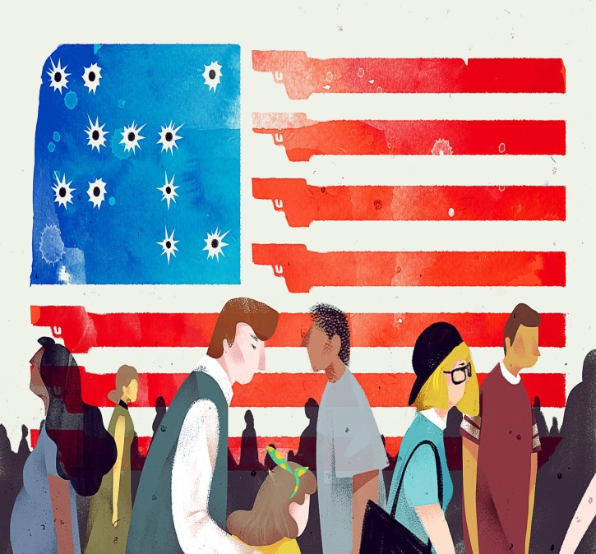
The Trigger
Effect of Gun
Violence on
Our Communities

When: September 20, 2019
6 CEU’s AVAILABLE FOR: LSW/LCSW, LPC/ LCPC, ICDVP
SPONSORED BY:

CEU Fee: $5 (Cash or Check Only)

6 FREE CEU’s FOR RN’S SPONSORED BY:


6 FREE MLE’S SPONSORED BY:


CONFERENCE HOSTED BY:


Participants will be able to download power point presentations prior to conference.
8:00-4:30 Conference
8:00: Registration
12:00-1:00: Wendell Jones
Awards Luncheon
Conference Fee: $50 (includes lunch)

Where: Wojcik Conference Ctr.
Harper College: 1200 W. Algonquin Rd.
Palatine, IL

Featuring:
Angalia Bianca- “Social Media & Gun Violence”
Palatine PD - “Gun Violence and Community
Impact”
IL State Police- “Clear & Present Danger”
Holly Rasche, NCH- “Active Shooters”

For more information and to
Register, visit Eventbrite.com

*Sign language interpreters available

